Physical Geology Date _________ Name ________________________
Volcanoes - Chapter 4
Dr. Jan Rasmussen jrasmussen@pima.edu www.janrasmussen.com

1. List the sequence of events leading to the eruption of Mount St. Helens on May 18, 1980.

2. List some of the effects of this eruption.

3. What are the three factors that determine the nature of a volcanic eruption and how do they affect the viscosity of a magma?

4. Compare, contrast, and give examples of 3 different types of igneous rock compositions.
Rock type | basalt | andesite | rhyolite
composition
Silica content
viscosity
fluidity
gas content
amount of pyroclastics
volcanic landforms

- Describe these types of volcanic materials:

pahoehoe flow

aa flows

lava tubes

pillow lavas

volcanic gases (volatiles)

pyroclastic materials

welded tuff

cinders

bombs

nuee ardente

lahar

flood basalts

lava domes

- Label these landforms on the diagrams below: caldera, plateau basalt, dike, sill, conduit or pipe, volcanic neck, fissure eruption, cinder cone, laccolith, batholith, stock

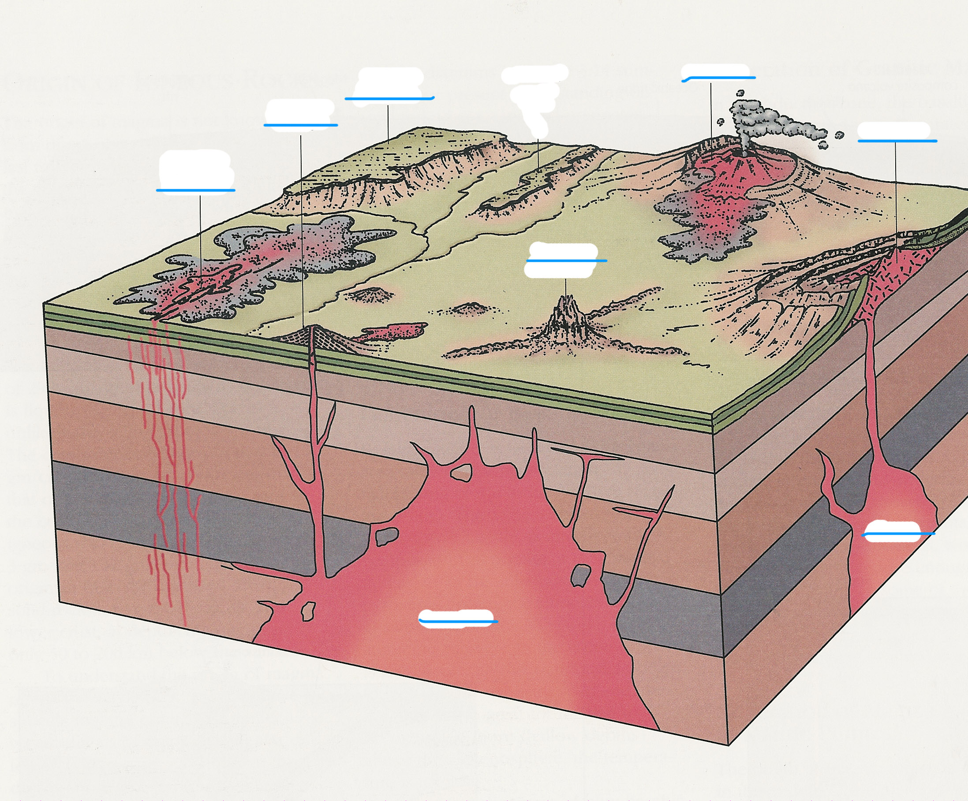
8. Compare, contrast, and give examples of 3 different types of volcanic environments: hot spots, subduction zones, and oceanic rifts.

characteristic | hot spots | subduction zones | oceanic rifts
rock type
violence of explosion
fluidity of lava
silica content of lava
examples
types of hazards
safe distance

